**DEPARTMENT OF INFORMATION TECHNOLOGY**

**Course Name and Code:** Data Structures Lab **(**ITL302)

**Semester:** III (Second Year)

**Academic Year:** 2021-22 (Odd Semester)

**Experiment No. 04**

**Aim:** Implementation of Double-ended Queue using Array for real-world application.

**Objectives:**

1. To introduce the concepts of data structures and analysis procedure.
2. To conceptualize linear data structures and its implementation for various real-world applications.

**Code :**

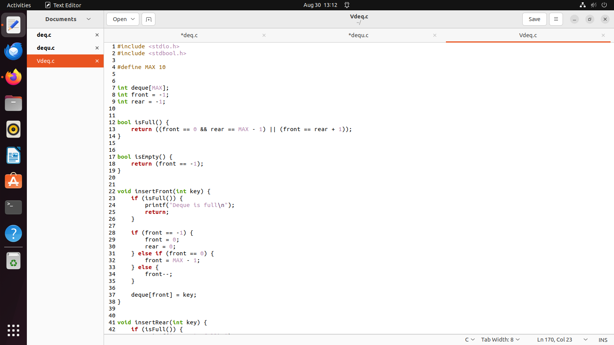

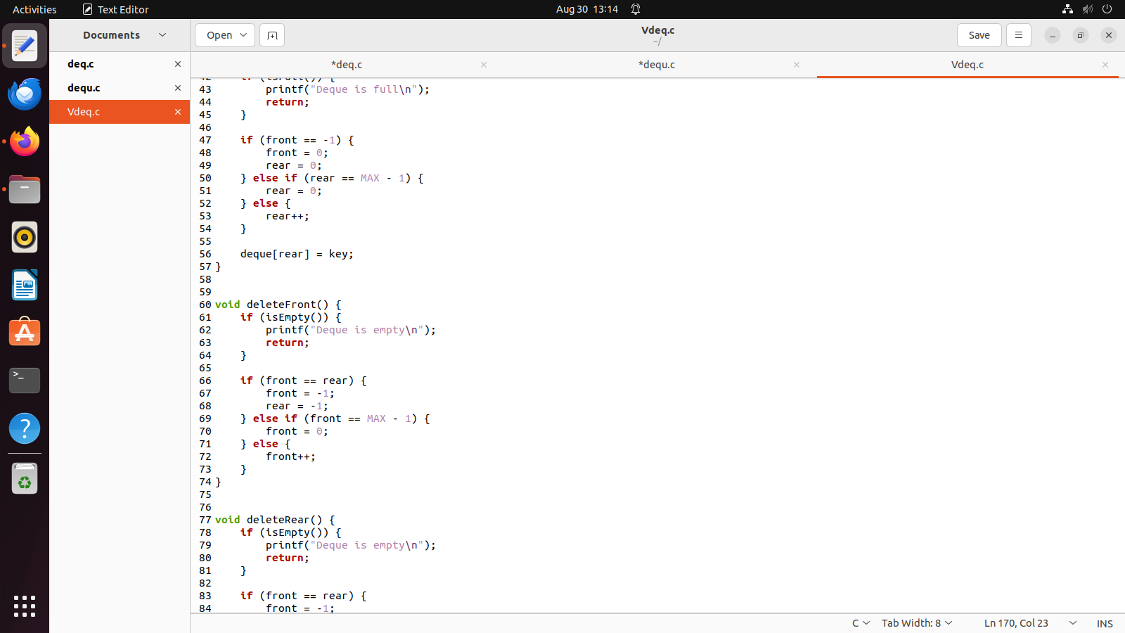

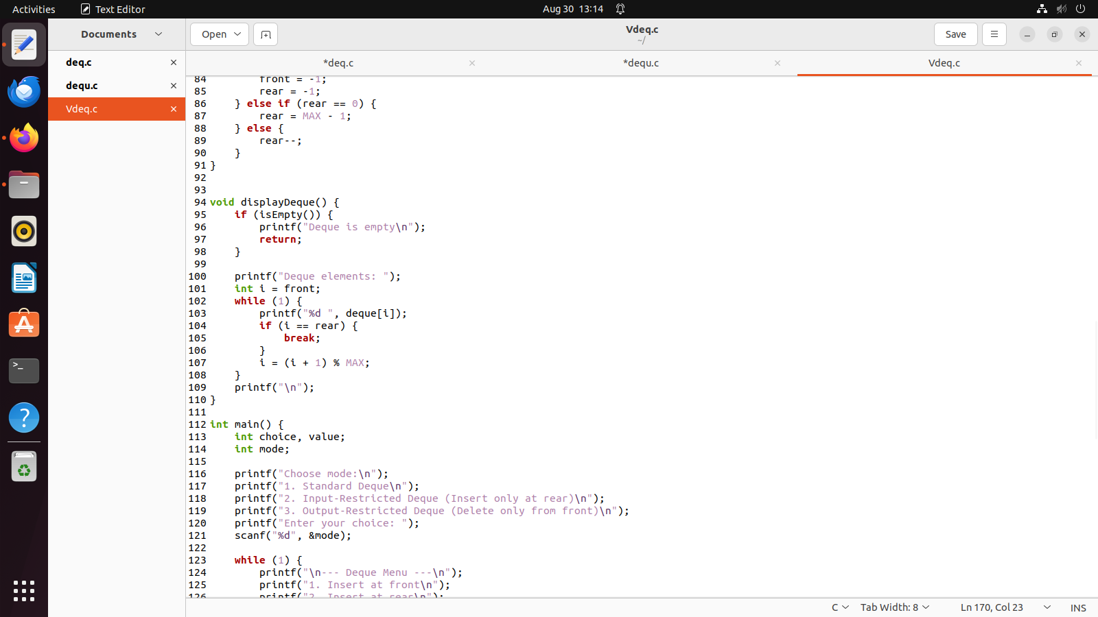

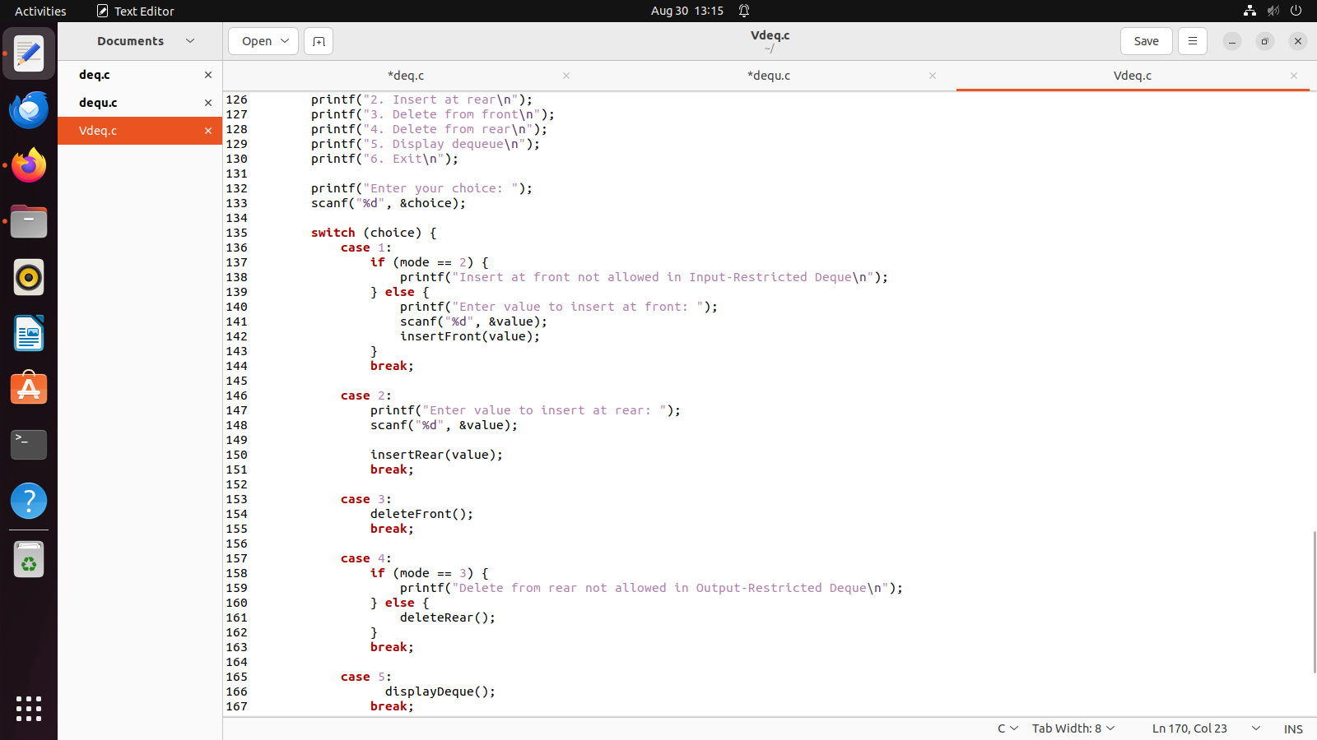

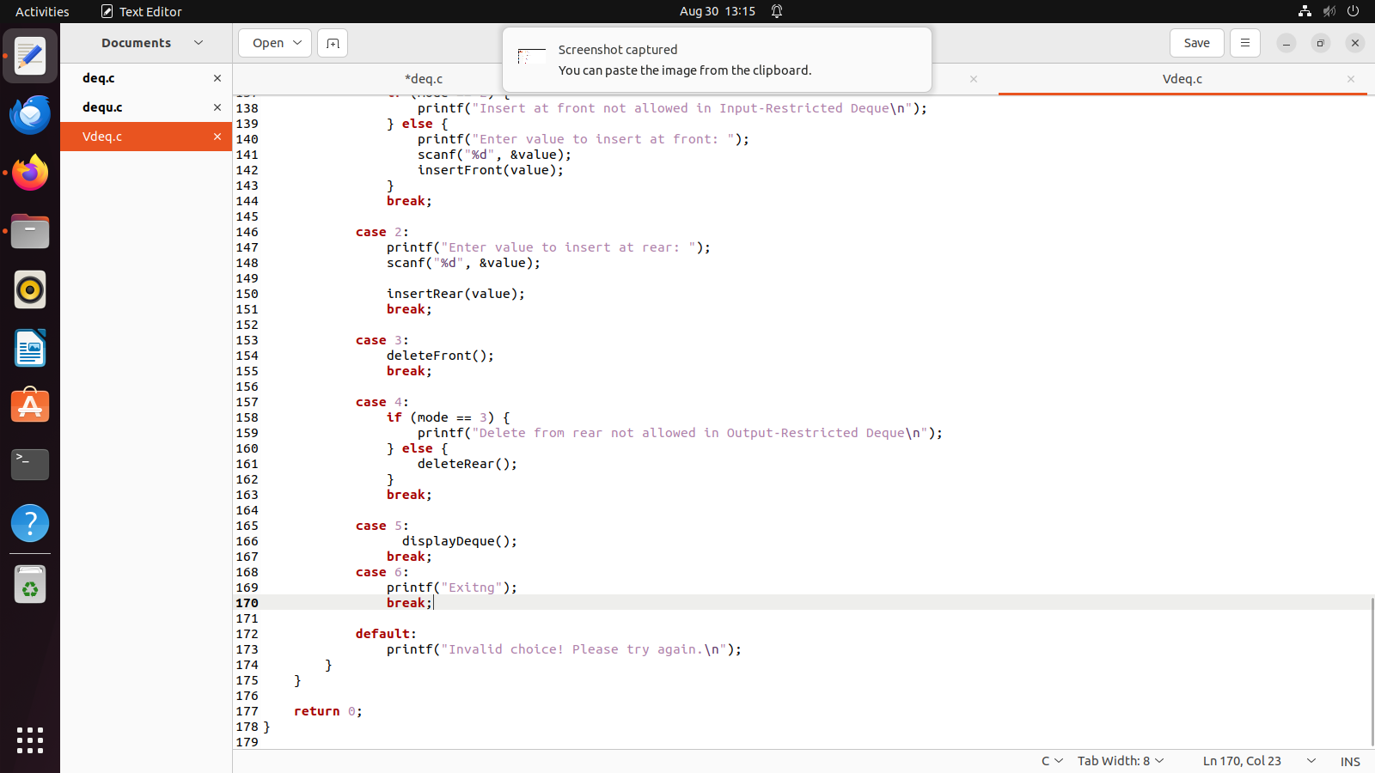

**OUTPUT :-**

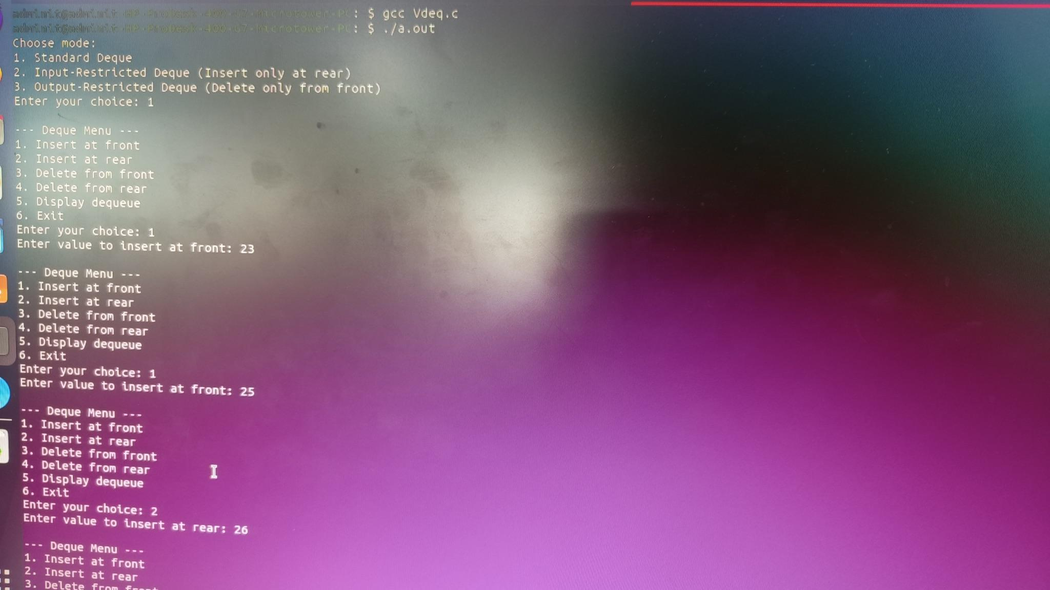

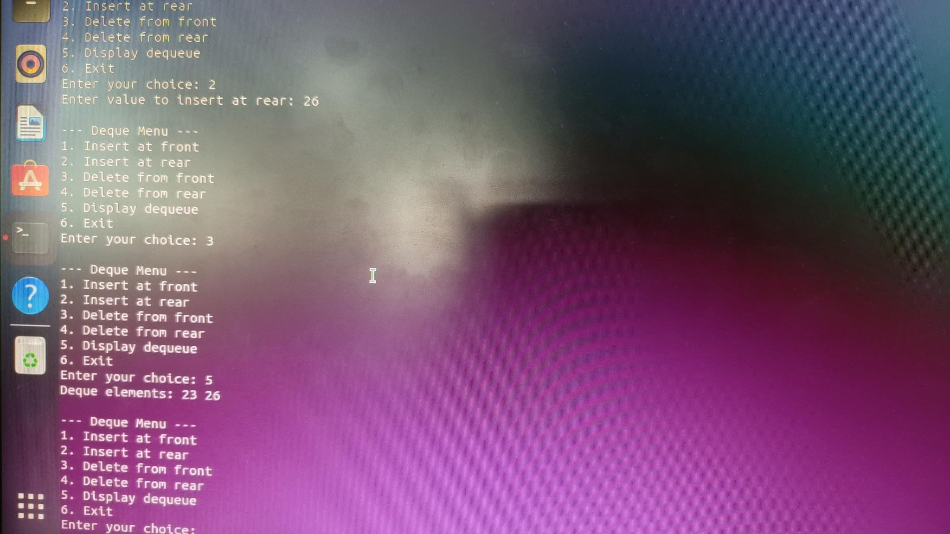

**Outcome:**

Apply the concepts of queues for real-world applications.

**SUBMITTER DETAILS:-**

**Name :- Veer Gokani**

**Div :- A/S2**

**Roll No:- 30**

**Date of performance :- 30/08/2024**